AgriNurture: Sustainable Fertilizer Recommendation System

Prof Renuka Singh

Department of Computer Science & Engineering (Data Science)

*ABESIT,Ghaziabad,India*

Ananya Sinha

Department of Computer Science & Engineering (Data Science)

*ABESIT,* *Ghaziabad,* *India*

[ananya2021csds074@abesit.edu.in](mailto:ananya2021csds074@abesit.edu.in)

Ayushree Mishra  
Department of Computer Science & Engineering (Data Science)

*ABESIT,* *Ghaziabad,* *India*

[chirag2021csds@abesit.edu.in](mailto:chirag2021csds@abesit.edu.in)

Chirag Yadav

Department of Computer Science & Engineering (Data Science)

*ABESIT,* *Ghaziabad,* *India*

[chirag2021csds@abesit.edu.in](mailto:chirag2021csds@abesit.edu.in)

## Abstract

**This** **paper** **reviews** **the** **integration** **of** **Artificial** **Intelligence** **(AI)** **and** **Internet** **of** **Things** **(IoT)** **technologies** **in** **soil** **health** **restoration** **systems.** **We** **analyze** **the** **smart** **sensing,** **data** **communication,** **and** **artificial** **intelligence** **systems** **which** **are** **used** **for** **soil** **classification** **and** **forecasting** **models.** **The** **use-** **definition** **connected** **with** **the** **precision** **agriculture,** **including** **the** **efficient** **irrigation** **and** **nutrient** **supply,** **is** **elaborated.** **New** **technologies** **like** **remote** **sensing** **and** **eco** **acoustics** **are** **also** **utilized** **for** **soil** **monitoring.** **The** **report** **describes** **the** **prospects** **of** **these** **systems** **as** **a** **way** **to** **increase** **agrarian** **sustainability** **despite** **the** **technical** **and** **operational** **problems** **that** **arise.** **The** **authors** **recommend** **possible** **interventions** **regarding** **the** **incorporation** **of** **AI** **and** **IoT** **in** **soil** **health** **management** **going** **forward.**

***Keywords****—****Artificial*** ***Intelligence,*** ***Internet*** ***of*** ***Things,*** ***soil*** ***health,*** ***precision*** ***agriculture,*** ***machine*** ***learning,*** ***smart*** ***irrigation,*** ***remote*** ***sensing***

Environmental factors constitute another key aspect of the predictive model. Crop development is greatly impacted by temperature, solar radiation, humidity, and rainfall patterns. Farmers may foresee potential problems and modify agricultural operations by using the ML model to create accurate environmental forecasts based on data from IoT- enabled sensors put in the fields and weather station data. For example, early interventions like irrigation scheduling or drainage management might lessen the negative impacts on crops in areas that are prone to drought or heavy rainfall.

1. Introduction

Soil health plays a highly significant role in sustainable agriculture. It directly relates to crop yield, food security, and the environment. The recent technological advancement in the domain of AI and IoT revolutionized the soil health monitoring and restoring patterns. The review paper attempts to synthesize the present researches available on AI and IoT- enabled soil health restoration systems, their applications, benefits, and challenges in modern agriculture.

The advent of IoT has allowed for real-time, continuous monitoring of soil parameters and has thus enabled unprecedented access to information for farmers and researchers on the moisture, pH, nutrient content, and temperature of the soil. Concurrently, AI has transformed how data could be analyzed, providing insights and predictions meant to guide decision-making in soil management and crop production.

This review discusses the various components of AI and IoT- based soil health restoration systems, from the sensor deployed and data-transmission methods to advanced AI/ML algorithms for soil analysis, classification and predictive analysis. We will also explore various use-cases of these technologies in precision agriculture, discuss emerging trends, and discuss the setbacks and future perspectives of this rapidly evolving field.

# Fig.1.Nutrients Parameters in the Soil

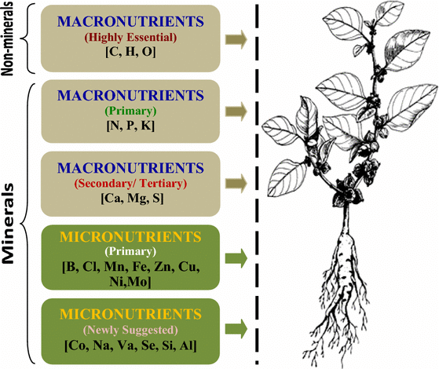

* 1. **Motivation**

The motivation behind the development of this soil health monitoring system stems from the need to make advanced agricultural technology accessible to small and medium-sized farms, which often lack the resources to implement expensive precision farming tools. This system aims to improvise the existing systems by incorporating low-cost, Arduino-based sensors with cutting- edge technologies such as Machine Learning, Computer Vision and IOT to allow farmers get real-time insights into their soil health.

# Objective

The primary objective of this paper is to develop an overview of a low-cost, Arduino-based system for soil health monitoring and explore its integration with advanced technologies for precision agriculture. Our contributions are:

## Real-Time Soil Health Monitoring

The system aims to provide farmers with immediate and accurate insights into the soil health using various sensors that monitor the temperature, moisture content, amount of rainfall, pH levels and nutrient content. This real-time data collection enables more informed decision-making and timely interventions to optimize crop health.

## Nutrient Analytics for Soil Classification

The system employs supervised Machine Learning algorithms to examine collected data and predict potential soil issues, such as nutrient deficiencies or water stress. This predictive capability helps farmers anticipate and mitigate problems before they impact crop yields.

## Crop Selection and Fertilizer Recommendation

Based on the analysis, this system contributes to sustainable farming practices by suggesting crops suited to the soil’s nutrient profile. For chosen crops, this system recommends fertilizers to address nutrient deficiencies.

# Problem Statement

This system addresses the critical challenge of **improving** **soil** **health** **management** and crop production through the **integration** **of** **Artificial** **Intelligence** **(AI)** **and** **Internet** **of** **Things** **(IoT)** **technologies**. The problem at hand involves developing an **AI-powered** **system** that can accurately analyze and **interpret** **soil** **health** **parameters** in real-time and provide recommendations to the farmers based on their desired crop.

# Literature Survey

The combination of AI and IoT in soil health monitoring and restoration has recently become a topic of increasing interest. This section provides an overview of key themes that we explored to understand and present these technologies and their applications in agriculture.

## IoT in Soil Health Monitoring

Several studies have explored the use of IoT for real-time soil health monitoring. Upreti et al. (2024) demonstrated the effectiveness of IoT sensors in measuring various soil parameters such as moisture, pH, nutrients, and temperature [1]. Their system utilized machine learning algorithms to analyze the collected data, optimizing resource use and improving crop yield. Kumar et al. (2021) developed a self- powered, real-time IoT system using LoRaWAN technology for continuous soil health monitoring [2]. This

study highlighted the potential of solar-powered nodes for sustainable, long-term soil monitoring, although challenges such as battery sustainability and data transmission range limitations were noted.

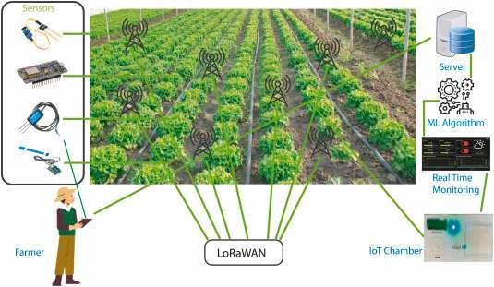

**Fig.** **2.** **IoT** **in** **Soil** **Health** **Monitoring**

## AI Applications in Soil Analysis

The application of AI, particularly machine learning, in soil analysis has shown promising results. Aydın et al. (2023) explored the use of advanced AI/MLalgorithms, specifically XGBoost and LightGBM, in soil classification [21]. Their study showed great accuracy rates exceeding 90%, significantly improving prediction accuracy when compared to previous researches.

Rahman et al. (2018) describes the use of Support Vector Machines (SVM) for soil classification and crop suggestion based on predicted soil series [22]. Their research showed outstanding performance of SVM over existing techniques in accurately classifying soil types, providing a valuable tool for agricultural decision-making.

## Precision Agriculture and Soil Health

The use of AI and IoT in precision agriculture has been a focus of several studies. Bwambale et al. (2022) investigated the use of data-driven model predictive control (MPC) for precision irrigation management [25]. Their research highlighted the possible use-cases of MPC in optimizing requirement of water through smart irrigation scheduling based on real-time soil moisture data.

Selvanarayanan et al. (2024) presented a counterfactual recommendation-based system for soil quality management in coffee farming [13]. This study demonstrated how AI- driven systems could provide actionable insights for soil restoration and crop management.

## Emerging Technologies

Researches in past years have also explored novel technologies for soil health assessment. Robinson et al. (2024) introduced the use of ecoacoustics for soil biodiversity monitoring [16]. This innovative approach uses AI to analyze sounds from soil organisms, offering a non-invasive method for assessing soil health.

Wang et al. (2024) conducted a comprehensive review of remote sensing applications in ecological restoration monitoring, emphasizing the importance of IoT, AI, and

block chain technologies in soil management [14]. Their work underscored the potential of integrating multiple technologies for comprehensive soil health assessment and restoration.

**Table** **1.** **Key** **Trends** **in** **Soil** **Health** **Monitoring** **Approaches**

|  |  |  |
| --- | --- | --- |
| **Approach** | **Accuracy/Performance** | **Reference** |
| **XGBoost** **and** **LightGBM** **for**  **soil** **classification** | >90% accuracy | [21] Aydın et al. (2023) |
| **Support** **Vector** **Machines** **(SVM)** **for** **soil** **classification** | 94.95% accuracy | [22, 23]  Rahman et al. (2018) |
| **J48** **(C4.5)**  **algorithm** **for**  **soil** **classification** | 91.90% accuracy | [24]  Gholap et al. (2012) |
| **IoT-based** **LoRaWAN** **soil** **health** **monitoring** **system** | Real-time monitoring, validated through field experiments | [26, 30]  Ramson et al. (2021) |
| **AI-enabled** **IoT** **system** **for** **soil** **nutrient**  **monitoring** | Improved efficiency compared to traditional methods | [33] Islam et al. (2023) |
| **Hybrid** **MLP-** **FFA** **model** **for** **spatial** **modeling** **of** **soil** **electrical**  **conductivity** | Outperformed standalone MLP and OK models | [35]  Ghorbani et al. (2019) |
| **AI** **techniques** **for** **generating** **national-scale** **topsoil** **thematic** **maps** | Improved prediction accuracy and spatial resolution | [36]  Samarinas et al. (2023) |
| **Active** **learning** **framework** **with** **AI** **and** **IoT** **for** **soil** **health**  **monitoring** | Significantly reduced operational costs with high-fidelity data | [37] Chen et al. (2023) |
| **Deep** **Learning** **(LSTM)** **based** **virtual** **soil**  **moisture** **sensor** | Outperformed traditional sensors in cost-  effectiveness and reliability | [49] Patrizi et al. (2022) |
| **Ensemble** **deep** **learning** **architecture** **for** **sustainable**  **agriculture** | Improved prediction accuracy (specific accuracy not provided) | [50]  Wongchai et al. (2022) |

Based on the comparison table, the best approach in terms of reported accuracy is the Support Vector Machines (SVM) for soil classification, with an accuracy of 94.95% [22, 23].

# Here are some key takeaways from the analysis:

* **Integration** **of** **technologies:** Many studies combine IoT, AI/ML, and data analytics for comprehensive soil health monitoring.
* **Real-time** **monitoring:** IoT-based systems, especially those using LoRaWAN, provide real-time soil health data, enabling timely interventions.
* **High** **accuracy** **in** **soil** **classification:** Machine learning techniques, particularly SVM and ensemble methods like XGBoost and LightGBM, show high accuracy (>90%) in soil classification tasks.
* **Multifaceted** **approach:** The best soil health monitoring systems address multiple aspects, including nutrient levels, moisture content, temperature, and even pest detection.
* **Sustainability** **focus:** Many studies emphasize the importance of sustainable practices and soil restoration alongside monitoring.
* **Cost-effectiveness:** AI and IoT integration often leads to more cost-effective solutions compared to traditional methods.

# IoT-based Soil Health Monitoring Systems

## Sensor Technologies

IoT-based soil health monitoring systems rely on a variety of sensors to collect crucial data on soil parameters. Common sensor types include:

* **Moisture** **sensors:** Measure soil water content
* **pH** **sensors:** Determine soil acidity or alkalinity
* **Nutrient** **sensors:** Assess levels of primary macro- nutrients- Nitrogen, Phosphorus, and Potassium (NPK)
* **Temperature** **sensors:** Monitor soil temperature

Recent advancements in sensor technology have prompted the creation of more accurate, durable, and cost-effective sensors. For instance, Upreti et al. (2024) highlight the use of advanced IoT sensors for measuring multiple soil parameters simultaneously, enhancing the efficiency of data collection [1].

.

## Energy Efficiency and Self-Powered Systems

Energy efficiency is a critical consideration in IoT-based soil monitoring systems, especially for remote or large-scale deployments. Solar-powered nodes have gained popularity as a sustainable solution. Ramson et al. (2021) present a self- powered soil health monitoring system using solar energy, enabling continuous operation and eliminate the need to replace batteries again and again[26].

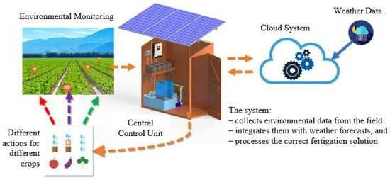

**Fig.** **4.** **Smart** **Self-Powered** **Irrigation** **and** **Fertilization** **System**

Additionally, scientists are looking into how to maximise battery life in these devices. Yang et al. (2024) discuss a distributed, self-powered soil monitoring system with independently functioning nodes that can work for up to eight days without recharging, suitable for long-term monitoring in remote farm environments [28].

# AI Applications in Soil Health Analysis

1. **Machine** **Learning** **for** **Soil** **Classification**

Machine Learning (ML) algorithms have significantly improved the accuracy and efficiency of soil classification.

* + Support Vector Machines (SVM): Rahman et al. (2018) showed that SVM performs better as compared to other methods in soil classification, achieving high accuracy rates [22].
  + XGBoost and LightGBM: Aydın et al. (2023) demonstrated that these advanced ML models achieved accuracy rates surpassing 90% in soil classification tasks [21].

**Table** **2.** **Comparison** **of** **Various** **Machine** **Learning** **Algorithms**

|  |  |  |  |
| --- | --- | --- | --- |
| **Study** | **ML**  **Algorithm** | **Accurac** **y** | **Application** |
| Aydın et al.  (2023) | XGBoost | >90% | Soil classification |
| Aydın et al.  (2023) | LightGBM | >90% | Soil classification |
| Rahma n et al. (2018) | Support Vector  Machines (SVM) | 94.95% | Soil classification |
| Rahma  n et al. (2018) | Weighted k-  Nearest Neighbor | Not specified | Soil classification |
| Rahma  n et al. (2018) | Bagged Trees | Not specified | Soil classification |
| Gholap  et al. (2012) | J48 (C4.5) | 91.90% | Soil classification |
| Gholap et al.  (2012) | Naive Bayes | Lower than J48 | Soil classification |
| Gholap et al.  (2012) | JRip | Lower than J48 | Soil classification |
| Ghorba | Hybrid MLP- | Outperfo | Spatial modeling |

These ML techniques enable more precise soil type identification, which is crucial for tailoring agricultural practices to specific soil conditions.

|  |  |  |  |
| --- | --- | --- | --- |
| ni et al. (2019) | FFA | rmed standalon e MLP  and OK | of soil electrical conductivity |
| Patrizi et al. (2022) | Long Short- Term Memory  (LSTM) | Not specified | Virtual soil moisture sensor |
| Wongc hai et  al. (2022) | Ensemble Deep Learning | Not specified | Soft sensor for sustainable agriculture |
| Islam et al. (2023) | Not specified | Not specified | Soil nutrients monitoring and crop  recommendation |
| Ali et al. (2024) | Not specified | High accuracy (exact %  not given) | Pest detection using sound analytics |

# Predictive Models for Soil Health

AI-driven predictive analysis models are tuned to forecast soil health trends and guide restoration efforts:

* Nutrient degradation prediction: Ahmed and Kamalakkannan (2022) developed an IoT-based data analytics system for predicting soil nutrient degradation levels, enabling proactive soil management [20].

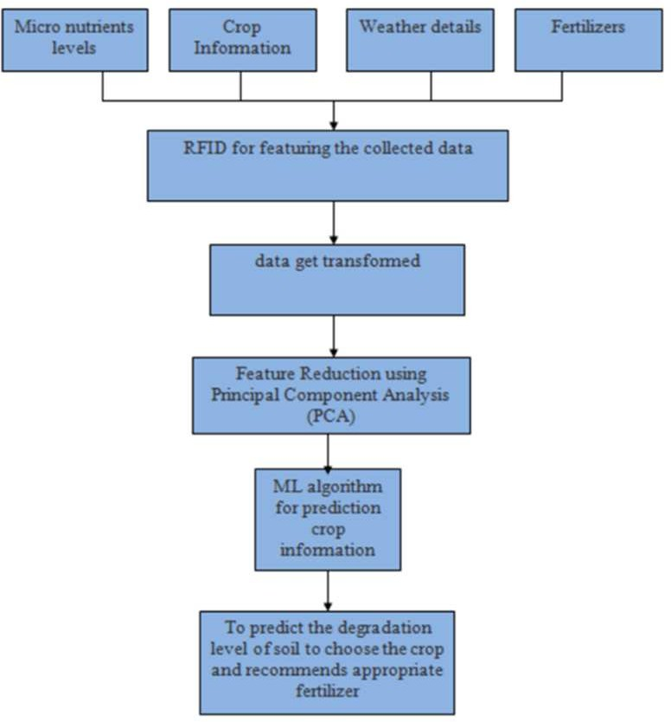

# Fig. 5. Flow Chart of Proposed Method [20]

* Soil restoration recommendation systems: Selvanarayanan et al. (2024) present a counterfactual recommendation-based system for soil quality management in coffee farming, demonstrating how AI can provide detailed, actionable insights for soil restoration [13].

# IoT Data and AI Integration

The integration of AI-enabled systems with real-time IoT data is enhancing the speed and accuracy of soil health assessments:

* Real-time data processing: Sharma et al. (2022) discuss the use of Edge computing for real-time soil data analysis, reducing latency in data processing [3].
* Edge computing applications: Akhtar et al. (2021) review smart sensing with AI and edge computing for soil quality monitoring, highlighting the potential for rapid, on-site data analysis [18].

# Precision Agriculture and Soil Health Restoration

* 1. **Smart** **Irrigation** **Systems**

AI-driven smart irrigation systems are playing a crucial role in soil health restoration:

* AI-driven irrigation scheduling: Bwambale et al. (2022) explore data-driven model predictive control (MPC) for precision irrigation management, optimizing water usage based on real-time soil moisture data [25].
* Water efficiency optimization: These systems can reduce the wastage of water drastically while ensuring that the soil still contains sufficient moisture levels for crop growth.

# Nutrient Management

AI-IoT technologies are revolutionizing nutrient management in agriculture:

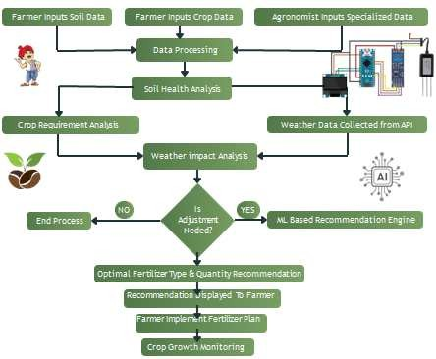

# Fig. 6. Crop Nutrient Management

* AI-based fertilizer recommendations: Systems can analyze soil nutrient data to provide precise fertilizer recommendations, reducing over-application and potential environmental harm.
* Precision application of nutrients: IoT-enabled systems can guide the targeted application of nutrients, ensuring efficient use of resources and promoting soil health.

## Crop Selection and Rotation

AI is enhancing decision-making in crop selection and rotation:

* AI-powered crop suggestions: Rahman et al. (2018) developed a system that suggests optimal crops based on classified soil types, promoting better alignment between crop selection and soil characteristics [23].
* Optimizing crop rotation for soil restoration: AI models can perform analysis on historical data and soil health parameters to recommend crop rotation patterns that enhance soil fertility and structure over time.

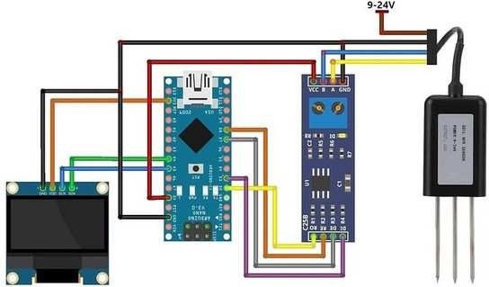

**Fig.** **7.** **Proposed** **Circuit** **Diagram** **of** **Soil** **Health** **Monitoring** **System**

1. **Advanced** **Technologies** **in** **Soil** **Health** **Monitoring**
   1. **Remote** **Monitoring** **and** **Satellite** **Imagery**

Remote monitoring and imaging technologies are expanding the scope of soil health monitoring*:*

* Integration with IoT systems: Wang et al. (2024) review the application of remote sensing in ecological restoration monitoring, and highlights its potential when combined with IoT and AI technologies [14].
* Large-scale soil health assessment: Satellite imagery allows for broad-scale analysis of soil health trends, complementing ground-based IoT sensors.
  1. **Blockchain** **for** **Data** **Security** **and** **Transparency** Blockchain technology is being explored to enhance data integrity in soil health monitoring:
* Ensuring data integrity: Blockchain can create immutable records of soil health data, ensuring the reliability of long-term monitoring efforts.
* Traceability in soil restoration processes: The technology can provide a transparent record of soil management practices and their outcomes, valuable for research and policy-making.
  1. **Ecoacoustics** **for** **Soil** **Biodiversity** **Monitoring** Innovative approaches like ecoacoustics are emerging in soil health assessment:
* Novel approaches to assessing soil health: Robinson et al. (2024) introduce the use of ecoacoustics for soil biodiversity monitoring as a means of soil health diagnostics [16].
* AI in sound analysis: Machine learning algorithms can be used to analyze acoustic data to assess soil biodiversity and overall soil ecosystem health.

# VII Challenges and Future Perspectives

1. *Technical* *Challenges*

There are several important technical issues that need attention:

* **Sensor** **durability** **and** **calibration**: One of the key challenges is ensuring that soil sensors remain accurate and reliable over time, especially when they're exposed to the tough conditions typical of agricultural environments.
* **Data** **integration** **and** **standardization**: Another challenge is maintaining proper standards for gathering and integrating data from various IoT and AI systems. This is essential to ensure we have high-quality datasets that are suitable for training and evaluating models effectively.

1. Implementation Barriers

When it comes to putting these technologies into practice, a few real-world obstacles exist:

* **Cost** **considerations**: The upfront investment required for IoT and AI technology can be quite substantial, making it difficult for some farmers to afford.
* **Farmer** **adoption** **and** **training**: Even if the technology is available, getting farmers to adopt these advanced systems and training them to use the systems effectively remains a challenge.

1. Future Research Scope

Looking ahead, there are several areas where research could make a big difference:

* **Development** **of** **more** **advanced** **soil** **sensors**: Future research might focus on creating more durable, multi- parameter sensors capable of measuring various aspects of soil health.
* **Robotics** **integration**: Another exciting area is the use of robotics for automating soil sampling and treatment, which could make the whole process more efficient.
* **Exploring** **AI** **in** **soil** **ecosystems**: There's a lot of untapped potential in using AI to model complex soil ecosystems and predict how they’ll react to climate

change, providing valuable insights for sustainable agriculture.

# VIII Conclusion

The use of AI and IoT in soil health monitoring and restoration is really changing the game when it comes to sustainable farming. These technologies allow for real-time data collection and smart decision-making, which helps farmers manage soil health more effectively. From smart irrigation [25] to precise nutrient management and choosing the right crops [22, 23], AI and IoT are making farming more efficient and sustainable.

As this field continues to grow, we can expect even more advanced systems that don’t just monitor the soil but also help restore and maintain its health over the long term. New technologies like ecoacoustics [16] and the combination of remote sensing with blockchain [14] are opening up fresh possibilities for managing soil health in a holistic way.

Ultimately, these AI and IoT-powered systems are going to play a big role in solving some of the world’s most urgent issues, like ensuring enough food for a growing population and protecting the environment in the face of climate change. By helping farmers make smarter, more informed decisions, these technologies will be key to building a more sustainable and resilient future for agriculture.

# IX REFERENCES

1. Ritu, Raj, Sondhiya. (2024). Smart Solutions for Sustainable Agriculture: Design and Development of IoT-Powered Soil Health Identification Systems. Deleted Journal, 31(4s):510-

519. doi: 10.52783/cana.v31.946

1. S., R., Jino, Ramson., Walter, D., Leon-Salas., Zachary, Brecheisen., Erika, J., Foster., Cliff, T., Johnston., Darrell, G., Schulze., Timothy, R., Filley., Rahim, Rahimi., Martin, Villalta, Soto., J., A., L., Bolivar., Mauricio, Postigo, Malaga. (2021). A Self-Powered, Real-Time, LoRaWAN IoT-Based Soil Health Monitoring System. IEEE Internet of Things Journal, 8(11):9278-9293. doi: 10.1109/JIOT.2021.3056586
2. Jordi, Surrallés. (2022). ETS: A Smart and Enhanced Topsoil Health Monitoring and Control System at Edge using IoT. doi: 10.1109/ises54909.2022.00153
3. Laavanya, Rachakonda. (2022). ETS: A Smart and Enhanced Topsoil Health Monitoring and Control System at Edge using IoT. 689-693. doi: 10.1109/iSES54909.2022.00153
4. Smieee, C.Rajasekaran., Ece, K.S.Rangasamy, Professor., Ece, M.Jeevanantham, Student., Ece, R.Jeeva, Student., Smieee, K.B.Jayanthi., Ece, R.Hariharan, Student., K.Raguvaran. (2024). An Integrating IoT for Intelligent Soil Analysis and Crop Optimization. doi: 10.1109/aimla59606.2024.10531447
5. Huynh,, Ethan., Pablo, Ramírez., Olimboyeva, Malohat. (2022). Smart agricultural remote monitoring system for better soil health using IoT. International Journal of Health Sciences (IJHS), 1239-1251. doi: 10.53730/ijhs.v6ns8.9885
6. R., Baskar., Golden, Kumar., Dragica, Karan. (2022). Smart agricultural remote monitoring system for better soil health using IoT. International Journal of Health Sciences (IJHS), doi: 10.53730/ijhs.v6ns4.9885
7. Rajan, Prasad., Rajinder, Tiwari., Adesh, Kumar, Srivastava. (2023). Internet of Things-Based Fuzzy Logic Controller for Smart Soil Health Monitoring: A Case Study of Semi-Arid Regions of India. doi: 10.3390/ecsa-10-16181
8. Vaibhav, Bhatnagar., Ramesh, Chandra. (2020). IoT-Based Soil Health Monitoring and Recommendation System. 1-21. doi: 10.1007/978-981-15-0663-5_1
9. Sashant, Suhag., Nidhi, singh., Sanskriti, Jadaun., Prashant, Johri., Ayush, Shukla., Nidhi, Parashar. (2021). IoT based Soil Nutrition and Plant Disease Detection System for Smart Agriculture. 478-483. doi: 10.1109/CSNT51715.2021.9509719
10. Holzinger, A., Keiblinger, K., Holub, P., Zatloukal, K. (2023). AI for life: Trends in artificial intelligence for biotechnology. New Biotechnology. doi: 10.1016/j.nbt.2023.01.001
11. Giannakidou, S., Radoglou-Grammatikis, P., Lagkas, T., Sarigiannidis, P. (2024). Leveraging the power of IoT and AI in forest fire prevention, detection, and restoration: A comprehensive survey. Internet of Things. doi: 10.1016/j.iot.2024.100523
12. Selvanarayanan, R., Rajendran, S., Algburi, S. (2024). Empowering coffee farming using counterfactual recommendation-based RNN-driven IoT integrated soil quality command system. Scientific Reports. doi: 10.1038/s41598- 024-56954-x
13. Wang, R., Sun, Y., Zong, J., Wang, Y., Cao, X., Wang, Y. (2024). Remote sensing application in ecological restoration monitoring: A systematic review. Remote Sensing, 16(12), 2204. doi: 10.3390/rs16122204
14. Singh, S., Jain, P. (2022). Applications of artificial intelligence for the development of sustainable agriculture. Agro- biodiversity and Agri-ecosystem Management. Springer. doi: 10.1007/978-981-19-0928-3_16
15. Robinson, J. M., Annells, A. (2024). Monitoring soil fauna with ecoacoustics. Proceedings of the Royal Society B: Biological Sciences. doi: 10.1098/rspb.2024.1595
16. Sharma, C., Pathak, P., Kumar, A., Gautam, S. (2024). Sustainable regenerative agriculture allied with digital agri- technologies and future perspectives for transforming Indian agriculture. Environment, Development and Sustainability. Springer. doi: 10.1007/s10668-024-05231-y
17. Akhtar, M. N., Shaikh, A. J., Khan, A., Awais, H., Bakar, E. A. (2021). Smart sensing with edge computing in precision agriculture for soil assessment and heavy metal monitoring: A review. Agriculture, 11(6), 475. doi: 10.3390/agriculture11060475
18. Elbasi, E., Mostafa, N., AlArnaout, Z., Zreikat, A. I. (2022). Artificial intelligence technology in the agricultural sector: A systematic literature review. IEEE Access. doi: 10.1109/ACCESS.2022.9999442
19. Ahmed, G. N., &Kamalakkannan, S. (2022). Developing an IoT-based data analytics system for predicting soil nutrient degradation level. *Expert* *Clouds* *and* *Applications*. Springer. https://doi.org/10.1007/978-981-16-2126-0_12
20. Yaren, Aydın., Ümit, Işıkdağ., Gebrail, Bekdaş., Sinan, Melih, Nigdeli., Zong, Woo, Geem. (2023). Use of Machine Learning Techniques in Soil Classification. Sustainability, doi: 10.3390/su15032374
21. Sk, Al, Zaminur, Rahman., Kaushik, Chandra, Mitra., S.M., Mohidul, Islam. (2018). Soil Classification Using Machine Learning Methods and Crop Suggestion Based on Soil Series. doi: 10.1109/ICCITECHN.2018.8631943
22. Rahman, S. A. Z., Hossain, M. S., & Uddin, M. N. (2018). Soil classification using machine learning methods and crop suggestion based on soil series. In Proceedings of the International Conference on Agriculture and Biosystems Engineering (pp. 25-30).
23. Gholap, J., Ingole, A., Gohil, P., Gargade, S., & Attar, V. (2012). Soil classification using data mining techniques and soil attribute prediction. In Proceedings of the 2012 International Conference on Computational Intelligence and Communication Networks (pp. 28-31). IEEE.
24. Erion, Bwambale., F., K., Abagale., Geophrey, Anornu. (2022). Data-driven model predictive control for precision irrigation management. Smart agricultural technology, doi: 10.1016/j.atech.2022.100074
25. S., R., Jino, Ramson., Walter, D., Leon-Salas., Zachary, Brecheisen., Erika, J., Foster., Cliff, T., Johnston., Darrell, G., Schulze., Timothy, R., Filley., Rahim, Rahimi., Martin, Villalta, Soto., J., A., L., Bolivar., Mauricio, Postigo, Malaga. (2021). A Self-Powered, Real-Time, LoRaWAN IoT-Based Soil Health Monitoring System. IEEE Internet of Things Journal, doi: 10.1109/JIOT.2021.3056586
26. Wolfgang, Krischke. (2022). IoT-Based Smart Monitoring of Soil Parameters for Agricultural Field. doi: 10.1007/978-981- 19-5224-1_60
27. Jianzhi, Yang., Yichen, Luo., Yixuan, Hou., Zili, Wu., Jiancong, Li., Yanxue, Guo., Yifei, Hu., Haotao, You., Xiaohui, Zhu., Yong, Yue. (2024). A Distributed and Self- powered Soil Monitoring Network for Smart Agriculture. doi: 10.1109/iccae59995.2024.10569382